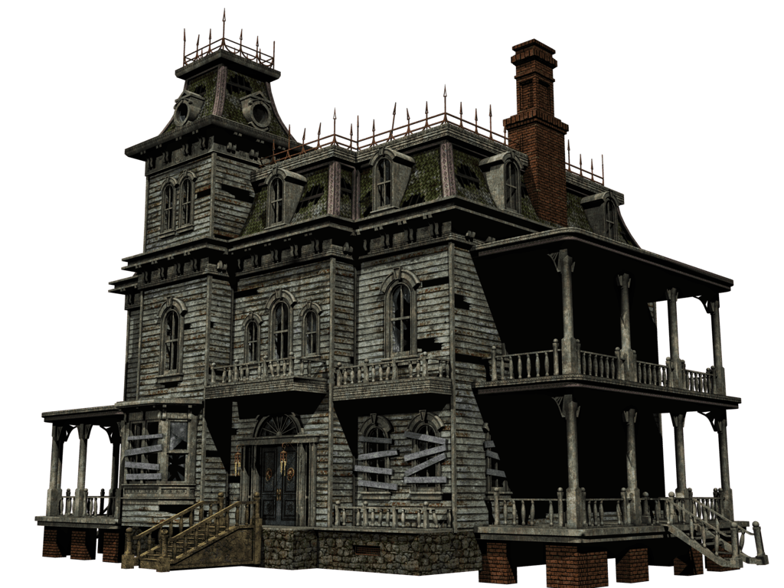

Demons aren’t real until you start running from them. Solve complex puzzles and riddles while avoiding *Abyzou*, the demon that hunts the house where you are now trapped, in order to escape.



* Solve several puzzles, from the easiest one to the hardest, in order to progress through the game and reach the antient loot box;
* Avoid the demon that hunts the house by solving things faster or at first try;
* Control Johnson Ash in a First-Person perspective and explore the house to find all the puzzles;
* Banish the demon by finding the long-banished loot boxes and recovering the forsaken artifacts;
* Learn the story of the Aarons to figure out what happened to this family and their house;
* Search for clues around the house to help you solve the puzzles;



The player must solve all the puzzles he is faced with, testing his/her intelligence and sharpness, in order to banish the demon that haunts the house in which you have lived since childhood. All your memories are one step away from being destroyed and try to escape from the possibility of becoming a Abyzou’s serve while doing all this in a horror filled environment.



Puzzle Solving with Horror theme.



Players that like horror themed and Puzzle Solving games.



Outlast, The Conjuring House, Emily Wants to Play, Layers of Fear.



Fully based puzzle solving game;

Heavy Horror elements;

Rich story background.



Purgatorium – Hell Bound is a single game meant to be played on PC developed using the Unity 3D Engine.



Intense Horror – Horror will fill the game since the beginning to the end with the intent to make the player anxious at all times during gameplay and use this anxiety to fail at puzzles or at finding clues for these puzzles;

Co-Related Puzzles – All puzzles need to be solved in order to make your way towards the end and sometimes some puzzles can lead to others making the player really think about what they’re doing.

Player-Story Relation – The game takes place in an old abandoned house, but before all this happened the house was home to a family. Find out about what happened to the previous inhabitants of the house before the demon made it it’s own.